**ME221-Mechanics of Materials -I**

**Deadline: 10 January 2024 (Submit Hard form in classroom)**

**CLO 2**



**Department of Mechanical Engineering**

**Assignment 2**

**Fall 2024**

**THIRD SEMESTER**

**Resource Person: Dr. Irsa Talib**

**Q:** The rigid bar *CDE* is attached to a pin support at *E* and rests on the 30 mm diameter brass cylinder *BD*. A 22-mm-diameter steel cylinder *AC* passes through a hole in the bar and is secured by a nut which is snugly fitted when the temperature of the entire assembly is 20 °C. The temperature of the brass cylinder is then raised to 50 °C while the steel rod remains at 20 °C. Assuming that no stresses were present before the temperature change, determine the stress in the cylinder.

Cylinder AC: Steel (*E* = 200 GPa, **a** = 11.7 x 10-6/ °C)

Cylinder BD: Brass (*E* = 105 GPa, **a** = 20.9 x 10-6/ °C)

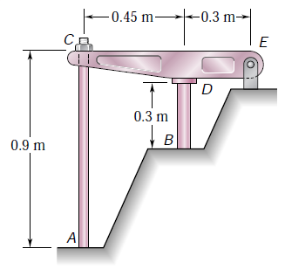

Further consider cylinder AC an unpressurized steel storage tank having outer diameter of 250 mm, wall thickness of 5 mm and ultimate strength of 420 MPa. Determine the maximum height *h* to which it can be filled with water if factor of safety 4 is required. Density of water is 9810 N/m3.

[5 Marks]